5D4N DANANG – HUE – HOI AN - CAM THANH - BANA HILL

DAY 1: DA NANG ARRIVAL – HUE ( D )
Arrival Da Nang International airport, meet and greet by our local tour guide. Depart to Hue by scenic drive via pass of Ocean Clouds and the scenic Fishing Village of Lang Co. Enjoy the beautiful landscape and panoramic views of the clouds, sea and mountain on the way. Arrival in Hue, enjoy Vietnam Royal Style dinner and overnight in Hue.

Meals: 1 Dinner
Accommodation: Overnight in Hue
The distance: Da Nang – Hue: 105km – 3.5 hours for transfer

DAY 2: HUE CITY TOUR – HOI AN (B/L/D)
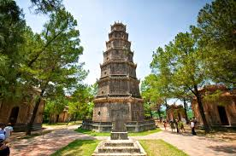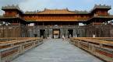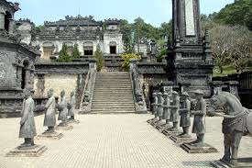
Thien Mu Pagoda Royal Citadel Khai Dinh Royal Tomb
Breakfast at hotel, take the boat trip to visit Thien Mu Pagoda then proceed to visit Royal Citadel, built on 1804. The tour of imperial City features Flag Tower, Noon Gate, Nine Dymastic Urns, Nine Holy Cannons, Thai Hoa Palace, Forbidden Purble city. After lunch, have a visit to Khai Dinh RoyalTomb. In the afternoon, transfer to Hoian, dinner and overnight in Hoi An.

Meals: 1 Breakfast + 1 Lunch + 1 Dinner
Accommodation: Overnight in Hoi An
The distance: Hue – Hoi An: 145km – 4.5 hours for transfer

DAY 3: HOI AN – CAM THANH – DANANG (B/L/D)
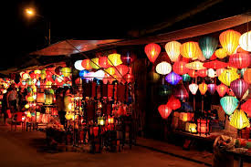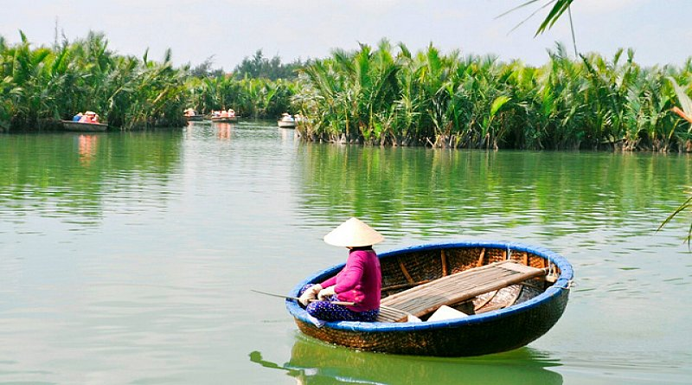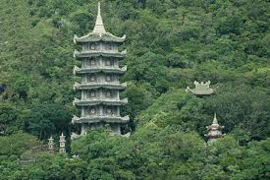
Hoi An Town Camthanh Marble Mountain
Breakfast at hotel, stroll around the Japanese Bridge, Phuc Kien Communal House, Tan Ky Traditional House, Museum, Handicraftsman At Work. Free time for shopping at Hoi An. After that, transfer to boarding the boat and travelling to Cam Thanh Water Coconut Village. While the boat cruises along the river, observing beautiful Hoi An rural lives with water coconut forest in the background. After that, transfer from the main boat to the bamboo basket boat and slowly rowing to the village and enjoy interesting show. Having an opportunity to learn how to row this unique bamboo basket boat and making an art out of coconut leaves. After lunch, back to Da Nang, stop to visit Mable Mourtain, arrival Danang, drive around the Son Tra Peninsula to admire the beauty of the whole city, visit Linh Ung Pagoda. Dinner & overnight at hotel in Danang.
Meals: 1 Breakfast + 1 Lunch + 1 Dinner
Accommodation: Overnight in Da Nang
The distance: Da Nang – Hoi An: 35km – 45 Minutes for transfer


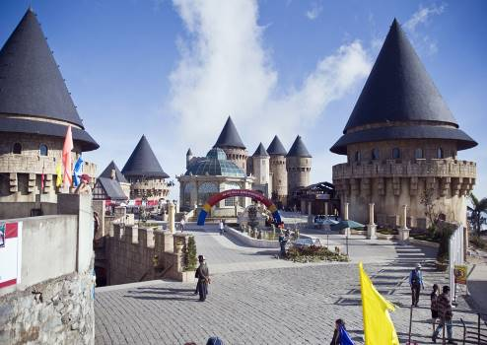
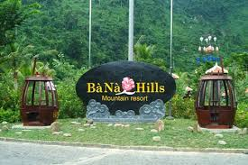
DAY 4: DANANG – BANA HILL (B/L/D)
Bana Hills
After breakfast, transfer to Bana Hills. You have a chance to ride on a modern system of cable cars helps you get a bird's-eye view, very miraculous and attractive. You will visit some old French villas en route, as well as the suspension bridge, Nui Chua & The Mountain Peak (at the height of 1,487m). Visit Vong Nguyet villa where we will visit the wine cellar, Linh Ung Pagoda, Sakyamuni Buddha's monument, Golden Bridge. Go down to Danang by cable car.

Meals: 1 Breakfast + 1 Lunch + 1 Dinner
Accommodation: Overnight in Da Nang
The distance: Da Nang – Ba Na: 35km – 45 Minutes for transfer

DAY 5: DA NANG DEPARTURE (B)
Breakfast at hotel. Free time until transfer to the airport for flight back home.

Meals: 1 Breakfast
The ends of program!

SEQUENCE OF ITINERARY SUBJECT TO LOCAL ARRANGEMENT

PRICE INCLUDE:
- Accommodation – as hotel in the list or similar – based on Twin/Double/Triple sharing
- Tour guide: English or Chinese speaking guide during the tour.
- Daily ABF and meals as mentioned in the program
- Shows and sightseeing in schedule.
- Transportation by private air-conditioner.
01 bottle ( 500 ml )of drinking water for each pax per day.
- Meals (Vietnamese Food & Chinese Food) as the tour code (B: Breakfast, L: Lunch, D: Dinner) 8-10 USD/meal/pax + 1 buffet luch at Bana Hills + 1 Royal Dinner.
- Sampan in Perfume River in Hue
- Cable Car at Ba Na Hill
- Bamboo basket in Cam Thanh
PRICE EXCLUDE:
- International / Domestic flight ticket & airport tax (if have)
- Personal expenses: Tel, Fax, Mini Bar, Laundry,etc.
- Personal travel insurance
- Compulsory Tip for local guide and driver (USD/pax/day)

Group Size | Tips in USD
2 – 4pax | 6
5-7pax | 5
8 - up | 3
- Additional Meal will be surcharge 10usd/pax/meal.
- Surcharge with other languages guide
- Surcharge at hotel case by case
  - Chinese New Year (TBA)
  - Gala Dinner on X’Mas (24, 25 Dec ) & New Year 31 Dec.

Hotel listed or Similar |  |  | All rates are next in USD/PAX  valid Jan – Dec 2020
 |  |  | Tour by private car / bus with private guide
HUE | DA NANG | HOI AN | 2 | 3-4 | 5-6 | 7-9 | 10-12 | 13-15 | 15+1 | 20+1 | 25 +1 | 30+1 | Sgl up
Thanh Lich 3*  Rosaleen 3* | Queen Finger 3*  King Finger 3*  Royal Charm 3* | Venus 3*  Lantern 3*  Rose Garden 3* | 463 | 402 | 338 | 305 | 282 | 278 | 275 | 258 | 248 | 241 | 76
Romance 4*  Asia 4*  Moonlight 4*  Emm 4*  Royal Boutique | Cosmos 4*  Greenery 4*  Aria Grand 4* | Hoi An Rosemary 4*  Green Heaven 4*  Emm 4* | 489 | 428 | 363 | 331 | 308 | 306 | 303 | 285 | 276 | 268 | 105

NOTE

The timing of sightseeing points shall be fixing by local operator due to traffic and weather conditions, however all points must cover unless amendment or cancellation make by clients themselves (Non-refundable for any cancellation that made by clients)

Tour and price are subject to change without notice or incase of deduct number of pax in quoted group.

Small deviations in the tour program are sometimes necessary, depending on weather, road conditions, flight schedules and room availability.

Supplement charge for room rate in peak dates depends on the hotel category used. Compulsory gala dinner on X’mas, New Year’s Eve & Lunar New Year’s Eve to be advised upon booking. Prices for group of 15 persons up in 5 stars hotels sometime requires to re-quote bases on the hotel policy

01 FOC for tour leader based on twin sharing basis include breakfast (domestic air ticket is not applicable).

BUS

Group Size | Kind of Transportation
1-2 pax | 4 seater
3 pax | 7 seater
4-9pax | 16 seater
10-18 pax | 30 seater
19-21 pax | 35 seater
22 – 42 pax | 45 seater

CHILD POLICY

- Infant below 2 years old sharing same room with parents is free of charge.
- Child below 12 yrs old sharing same room with 1 ADL is charged for 90%.
- Child below 12 yrs old with extra bed and sharing same room with parents is charged for 65%.
- Child below 12 yrs old No extra bed & sharing same room with parents is charged for 55%

